Dept.ofCSE

# Summer Internship mini- project (R21)

# 

# Department of Computer Science & Engineering

PACEINSTITUTEOFTECHNOLOGYANDSCIENCES(AUTONOMOUS) NH-16,ONGOLE,PRAKASAM(DT), ANDHRA PRADESH.

For III B.Tech I Semester

**Age calculator using python**

**( Calculate how old am I )**

**ABSTRACT:-**

The **age calculation formula** is quite simple. It goes like this:

**Year of birth – current year = age**

For example, if you were born in 1990 and it is now 2023, your age would be 2023 – 1990 = 33 That’s all there is to it! It’s important to note that this formula only works for calculating your chronological age. Things get a little more complicated if you want to calculate your biological age. Several factors contribute to your biological age, including lifestyle choices, genetics, and environmental factors. To get an accurate reading of your biological age, you’ll need to consult with a doctor or other medical professional.

**Introduction:-**

The age of a person can be counted differently in different cultures. This calculator is based on the most common age system. In this system, age increases on a person's birthday. For example, the age of a person who has lived for 3 years and 11 months is 3, and their age will increase to 4 on their next birthday one month later. Most western countries use this age system.

In some cultures, age is expressed by counting years with or without including the current year. For example, a person who is twenty years old is the same age as another person who is in their twenty-first year of life. In one of the traditional Chinese age systems, people are born at age 1 and their age increases up at the Traditional Chinese New Year rather than their birthday. For example, if one baby is born just one day before the Traditional Chinese New Year, 2 days later, the baby will be 2 even though he/she is only 2 days old.

In some situations, the months and day result of this age calculator may be confusing, especially when the starting date is the end of a month. For example, we count Feb. 20 to Mar. 20 to be one month. However, there are two ways to calculate the age from Feb. 28, 2022 to Mar. 31, 2022. If we consider Feb. 28 to Mar. 28 to be one month,

Understanding the working of the Age Calculator

A definition from the Oxford dictionary says that "**Age**" is the length of time that a person has lived, or a thing has existed. The age calculation method includes comparing the date of birth of a person with the date on which the age is required to be calculated. Thus, a person's age is equal to the date of birth subtracted from the given date. The following equation states the same.

**Person' s Age = Given Date - Date of Birth (D.O.B.)**

The following are the steps that allow us to calculate someone's age from their date of birth to a given date:

**Step 1:** Firstly, we will find the difference between the specified year and the birth year, i.e., Specified Year - Birth Year. Note that a fully completed year is considered.

**Step 2:** Secondly, we will estimate the number of remaining months. Since we only consider a fully completed year, a certain number of months will be left out that require to be estimated.

**Step 3:** Lastly, we will consider the remaining days. This provides us with the final age of a person. It is expressed in years, months, and days.

Python Program to Calculate Age

Let us now create a Python program to calculate the age on the current date. We will define a function that will calculate the age for the given data. We will later modify this function and use it in the application we build later in this tutorial with the help of the Python Tkinter library.

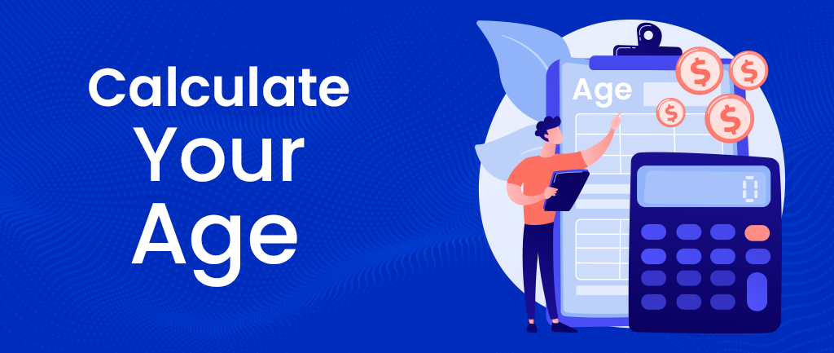

**Explanation:-**

We have imported the **date** module from the **datetime** library in the above code snippet. We have then defined a function as **calculate_age()** that accepts an argument as '**birthday**'. Within this function, we have retrieved the current date using the **today()** method of the **date** module. We have then checked whether the current day and month are less than the day and month of the birth and stored the Boolean result in a variable as **day_check**. We have then calculated the difference between the current year and the birth year. However, this difference is not enough. To get it correct, we must subtract **0** or **1** based on whether today precedes the birthday month and day from the year difference. This can be done by subtracting the Boolean value

stored in **day_check** from the value stored in the **year_diff** variable. Note that the Boolean value will be converted from **True** to **1** and **False** to **0** under the operation. We have also calculated the remaining months by subtracting the birth month from the current month and stored an absolute value in a variable. We have done the same to calculate the remaining days. We have then printed the calculated age for the user. We have then defined the main function. Within this function, we have printed an opening statement for the user. We have then asked the user to input the year, month, and day. We have then stored the input data in the date format using the **date()** method. At last, we have called the function to calculate the age of a person.

**Example:-**

|  |  |  |  |  |
| --- | --- | --- | --- | --- |
| **Date of birth** | **Current date** | **year** | **MONTHS** | **DAYS** |
| **01-02-2000** | **10-09-2023** | **23** | **7** | **9** |
| **09-12-2002** | **10-09-2023** | **20** | **9** | **1** |
| **18-08-2003** | **10-09-2023** | **20** | **0** | **23** |
| **10-09-2001** | **10-09-2023** | **22** | **0** | **0** |

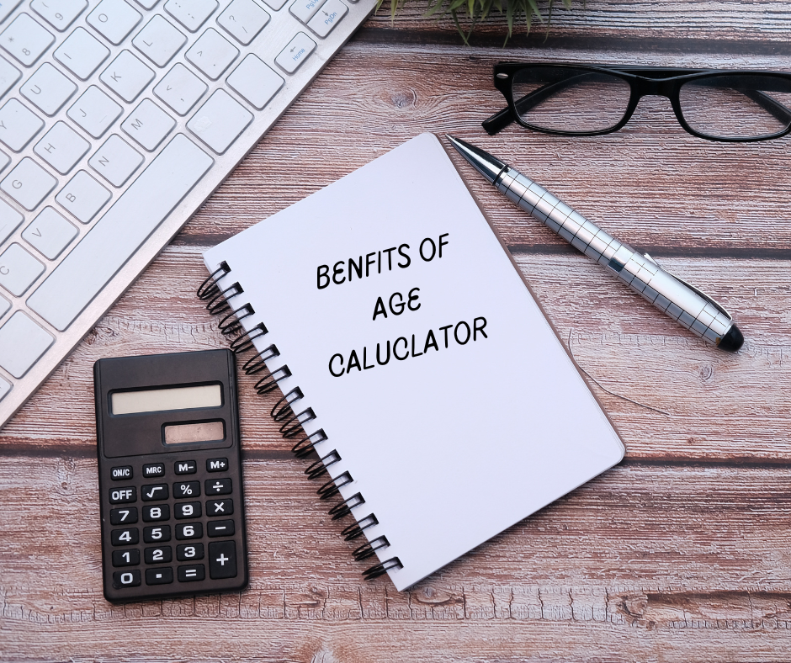Benfits :-

### Get an exact age

The Age Calculator will give you an exact age down to the day. This is useful if you want to know your precise age for legal purposes or personal records.

### Check if you’re old enough for certain activities

Some activities have age restrictions, like gambling or drinking alcohol. Knowing your **exact age** can help you ensure you’re not doing anything illegal.

### Know your biological age

The **Age Calculator** can tell you your chronological age and biological age, which is the age of your body and its organs.

### Determine your eligibility for age-related benefits

Knowing how old you are can determine if you’re eligible for certain age-related benefits like retirement savings or discounts.

### Check if you are at risk of developing age-related diseases

The Age Calculator can help you check if you risk developing age-related diseases This is helpful information to have if you want to know if you need to take steps to prevent certain conditions.

## **Conclusion**

There are many reasons why you may want to use an age calculator. Some of the most popular reasons include determining your biological age, comparing your actual age to your chronological age, and determining your life expectancy.

Age calculators can be helpful in understanding your health and making important decisions about your future. If you’re curious about how aging affects you, consider using an age calculator.

